**Exercise – Calculator**

The first part in the recruiting process is to develop a little project to show us your coding skills.

**Project specifications**

You will create a Calculator page.

The user will type a number then choose an operator from a drop down and choose another number. The result will be calculating at server and then display to the user

Also, all the user's calculations will be display in a "calculation history".

The user can DELETE a calculation and UPDATE a calculation (when pressing update the calculation will be display in the inputs, and the user will be able to change it and the change will update at the list.

When press F5 all the user history will be display

**Requirements:**

* All operations and results types should be exposed from Rest API.
* Implement the exercise with adhering to OOP/OOD concepts.
* **Implement application that will be closed for changes and open to extensions (for example add additional operations).**
* Make sure you leave a Readme.md file so we can how to run the project.
* We appreciate clean code, make sure you leave comments so we can understand your code.
* Make sure to handle exceptions.

**Technologies**:

React, .Net Core

You have 4 days from today, submit your project by sending the link to

mkorotayev@isracard.co.il

rozamir@isracard.co.il

ahgrossman@isracard.co.il

Good Luck!

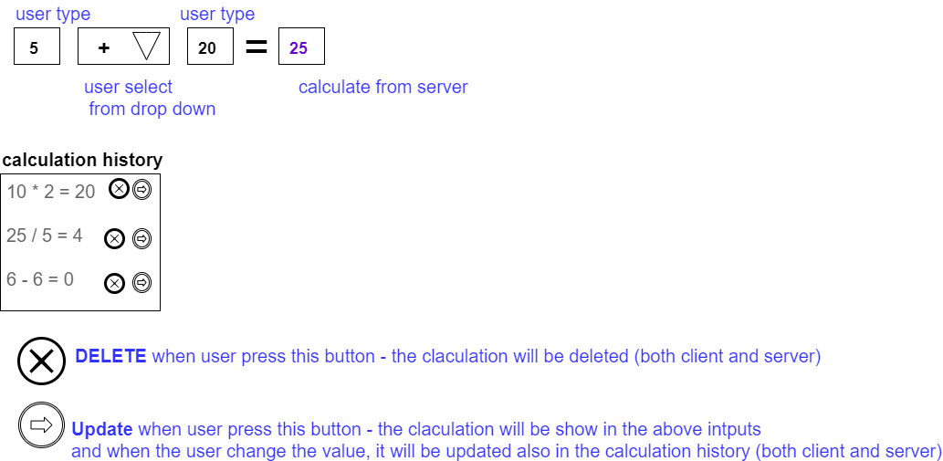This is how the UI should look like (in blue comments for explain)